

**NORTHEASTERN UNIVERSITY**

Toronto, Canada

**Final Project Report- Hospital Management System**

Database Management Systems

(ITC6000)

Submitted by:

Name: Dhruvang Patel

NUID: 002195090

Date: 07th April, 2022

Under the guidance of:

Prof. Anis Sharafoddini

**INTRODUCTION:**

According to the report of Statista, in 2013, the global healthcare data was about 153 exabytes of global hospitals and it was increased to 2,314 exabytes in the year 2020. On a day-to-day life, hospitals interact with a plethora of people and do a range of duties, including making appointments, monitoring specialist schedules, updating diagnosis of patient, and maintaining patient’s past medical condition, among other things. This application's goal is to demonstrate how databases may aid in data management for commitments. The health information system (HMS) is a smartphone app that manages all elements of surgical treatment, including health data.

The HMS assists the medical staff in expediting all important procedures, such as patient cooperation, job completion, financing administration and maintains your person’s entire clinical notes, through assessment to medical exemption, for healthcare professionals.

1. How the app or service is used, who uses it and why?

This is a hospital management programme that allows patients to schedule appointments and view their medical records, as well as the hospital administration to keep track of patients to ensure that the system runs smoothly. Even physicians can keep track of their schedules and patient information in advance.

1. The app's cost model.

This programme was created with all sorts of patients in mind, thus it is primarily free. However, there are certain premium services available at a minimal membership cost, such as having an assigned online doctor 24 hours a day, lab tests, and other premium services.

1. Personal connection to this app or service.

I witnessed the circumstances of Covid-19, when hospitals were critical for each patient. So, at that time, I went to a super-specialty hospital that had all of the top-of-the-line amenities and services. However, paper-based records were still used in tiny hospitals. As a result, I decided that this premium service should be made available to everyone at a low cost. That's when I got the idea to create a Hospital Management System so that everyone may keep track of their health.

**BUSINESS ANALYSIS:**

* The primary goal of this application is to collect patient data.

USER: Patients, Doctors, Administration

User Entities: ID, Name, Email, Gender, Password, Address

* They are then asked to schedule a meeting and explain their concerns or concerns, following which they will be given an assessment number, timing and date.
* Specialists now check their complete schedule for appointments to see total number of patients they have, and when patients come, he evaluates writes medications.
* If the patient is a new case, a fresh health record will be created for them; if the patient is already on file, the record will be sent to the doctor prior to the consult so that he could obtain a brief review of the patient.
* Data Creation: The information provided by the patients about their medical condition and the information provided by the doctors about patients’ medication and surgeries are the data which are created.
* Data Storage: The majority of hospitals employ highly secure Storage Area Networks (SAN) to store data for all the sensitive data and Cloud environment is ideal since it provides both storage and security, as well as latency and privacy, as required by the hospital.
* Data retrieve: We may use typical SQL queries to obtain data from the database, which can display data of our choosing.

**APPLICATION SOLUTION:**

1. Keep digital records.
2. Improved Departmental Collaboration.
3. Follow the Process Without Making Mistakes.
4. Time-saving and effective.
5. Patient Participation.

**BUSINESS CHALLENGES:**

* An underperforming delivery network.
* Computers have a range of concerns that need to be addressed.
* There are no data entry or retrieval standards in place.
* Teaching individuals how to use HMS on a technical level is difficult.

**USE-CASE DIAGRAM:**

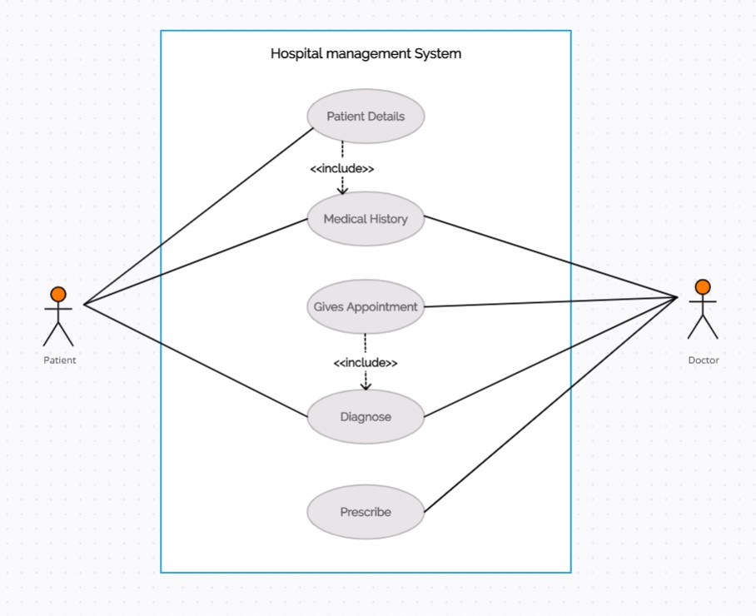

**TABLE DESIGN AND ANALYSIS:**

My table design consists of:

1. Patients
2. Medical History
3. Doctors
4. Schedule
5. Appointments

* The Medical History table is for patients and physicians to update drugs and surgeries, as well as for patients to update their medical problems.
* Doctors and schedules table are linked, with doctors being able to edit their schedules under the schedule table.
* The doctor's schedule and the appointment table are linked, and an appointment may be made simply glancing at the doctor's schedule.
* The patient table is linked to appointments, and it allows patients to arrange appointments with any doctor who is available for treatment, as well as track the status of their appointments.
* A patient table is linked to a physicians table, where doctors may see patient information.

**ENTITY-RELATIONSHIP DIAGRAM**

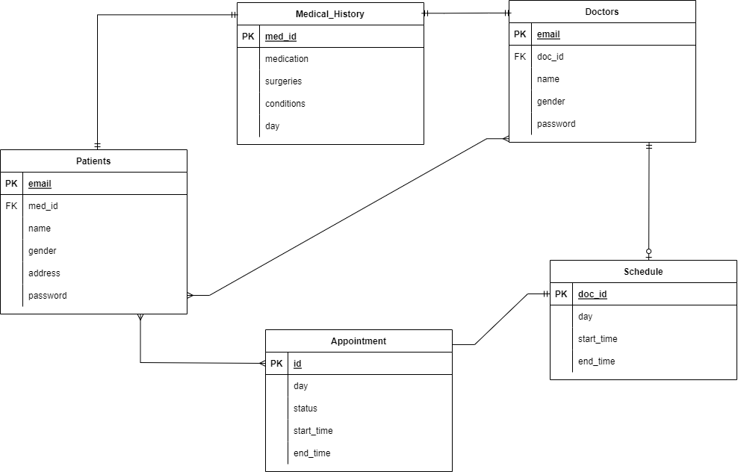

**DATABASE IMPLEMENTATION:**

1. Firstly the data which was inserted in patients table was retrieved using SELECT query where all the information of patients is stored.

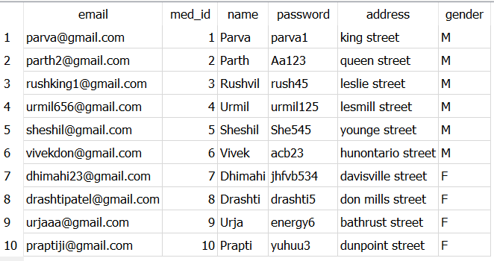

1. After that when the patients tell their medical condition the condition is updated in medical condition table with UPDATE function.

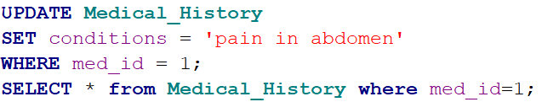

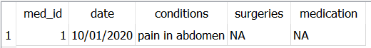

1. Now we need to give appointment to the patients by looking at the schedule of the doctors for which we have to retrieve the data of schedule table which contains data of summary of a doctor’s schedule using JOIN function.

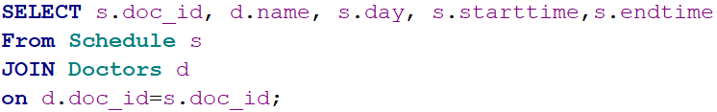

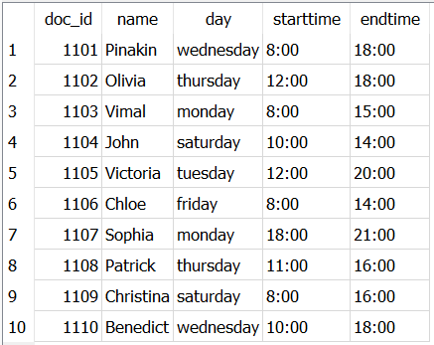

1. Now I want to know the medical condition of patient named Urmil, his appointment date and the doctor appointed to him.

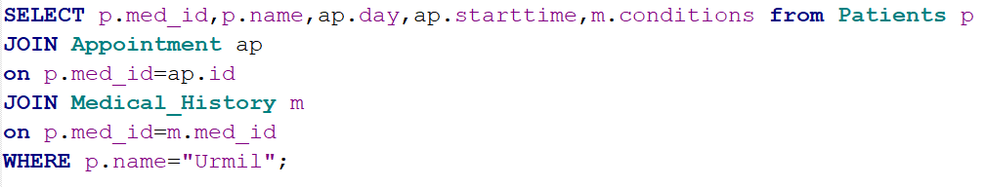

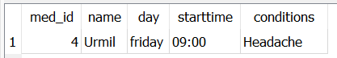

Now in this only the administration wants to see which doctor is available for treatment.

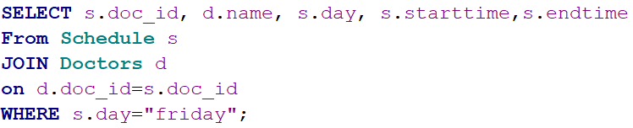

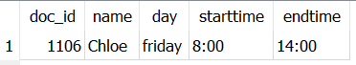

After running the query we got that urmil had a headache and his appointment was scheduled only Friday and from the schedule and doctor’s table we got to know the doctor’s name which is available on Friday.

1. Now after checking the patient(Urmil) the doctor needs to update the medication and surgery(if applicable) of the patient to the medical history table. For that UPDATE query is used again.

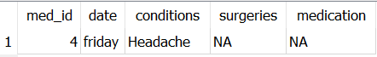

This is the output before updating the table.

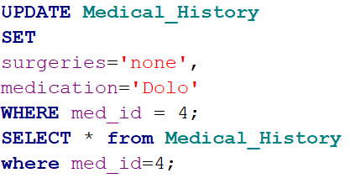

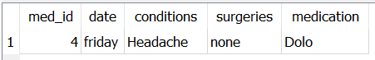

This is the updated table of medical history of Urmil where medication and surgery is updated.

**ANALYTICS, REPORT AND METRICS:**

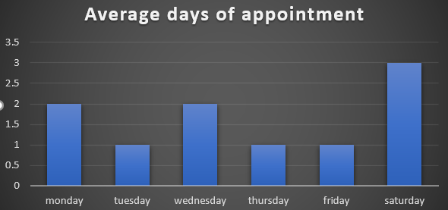

*Figure 1: Average days of appointment*

* Figure 1 shows the average number of appointments offered to patients on different days of the week, with Saturday having the most, followed by Monday and Wednesday.

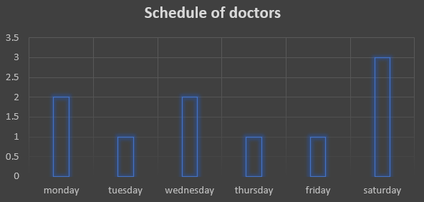

*Figure 2: Average days of schedule of doctors*

* Figure 2 shows the doctor's schedule, and it's clear that doctors are most available on Saturdays, with Monday and Wednesday coming in second and third.

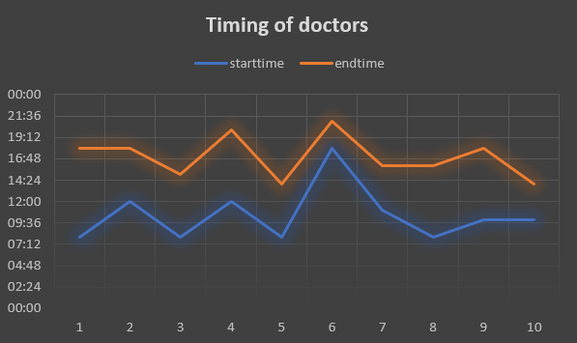

*Figure 3: Timing of doctors*

* Figure 3 tells us about the timing of the doctors which varies around certain timing. We can say that average start time of doctors is around 9-10 AM and end time is around late evenings.

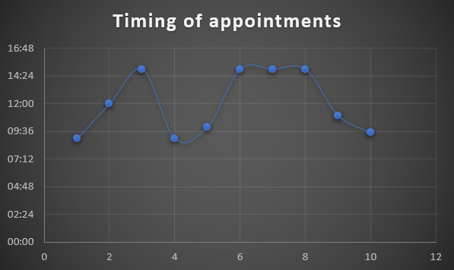

*Figure 4: Appointment timing of the patients*

* Figure 4 tells us the timing of the patients and we can say that patients either choose early morning or mid-afternoon for appointments.

REPORT:

* According to the aforementioned information, the hospital is busiest on Saturdays, Mondays, and Wednesdays. Doctors work for an average of 6-7 hours every day, whenever they are available.
* Patients' appointments are generally in the afternoons, with just a small percentage of the population choosing to arrive in the morning.

**SQL COMMANDS:**

* One of the patient wants to know the availability of “Dr. Victoria”, so for that JOIN command was used to join doctor and schedule table.

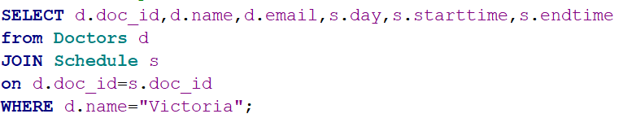

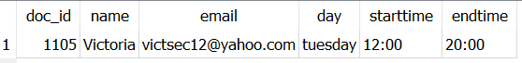

* One of the doctors who arrive on Saturday wants to know the information of patients arriving on that day with timing from set from morning to evening. Here total two tables were joined to patients table and order by command was set for start time.

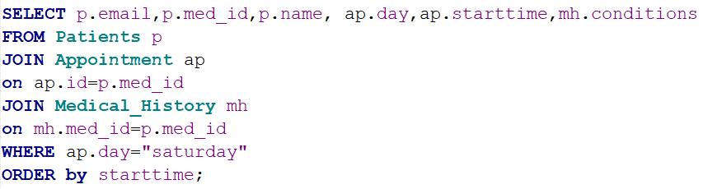

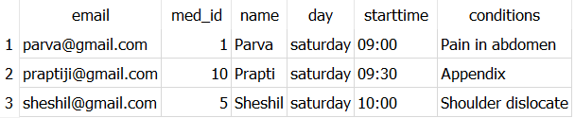

**SECURITY CONCERNS:**

The absence of security in the HMS is one of the most critical flaws. Going online without sufficient protection is considered a matter for concern, since this might result in major security difficulties.

* Staff: Patient files are easily accessible to staff. While the vast majority of people will not misuse their position, there is no certainty that some would.
* 3Vendors**:** Healthcare providers sometimes work with suppliers without first analysing the risk involved. Vendors like lab organizations, pharmacy its employees might gain access to the information.
* Unencrypted mobile devices**:** Security requirements aren't always followed by healthcare organisations that allow mobile logins. Because the administration’s planning and security does not include staff communication devices, viruses and hackers have access to the network.

**ARCHITECTURE:**

* In this application, the model's clients will be patients and physicians. The Hospital Database server will respond with a professional healthcare worker (doctor) and an appointment when patients update their medical conditions in the application server.
  + Presentation Tier: The customer (patient) provides information about their ailment or condition in order to schedule an appointment with a doctor.
  + Application Tier: The client's issue statement is passed to the application server, which constructs a query and sends it to the database layer.
  + Data Tier: This is where the database system executes the query, looks for a doctor, and schedules the client's appointment.
* For my application, such as IBMdb2 and Oracle databases, I picked cloud storage. The Cloud environment is ideal for healthcare data management because it provides storage, security, latency, and privacy, all of which are tailored to the hospital's needs.

**PROJECT WRAP UP AND FUTURE CONSIDERATION:**

* This project improved my grasp of SQL, how databases function, and how to run complex queries. How can SQL manage massive data, which is stored in the billions in our everyday routines.
* The knowledge of business analysis and how client/server architecture is used in a system which will help the server hosts, provides, and controls the majority of the client's resources and services.
* I learned about the world's healthcare system and how vast, sensitive data about each patient is saved in a database and utilised in day-to-day life as a result of the project topic – Hospital management system.
* The future of healthcare data is incredibly bright, since trillions of bytes of data are created every year, and it is critical to properly handle the data.
* Second, it is critical to educate hospital employees and administration about the database system, which will aid in database management.
* Complex SQL queries such as JOIN, GROUP BY, ORDER BY, and others are used to obtain data from several databases in SQL.
* ER-Diagrams (ERD) are important in database administration because they allow us to see the connection between multiple tables.

**REFERENCES:**

1. *A detailed view of Hospital Management System (HMS)*. (n.d.). A Detailed View of Hospital Management System (HMS); mocdoc.in. Retrieved April 7, 2022, from <https://mocdoc.in/blog/a-detailed-view-of-hospital-management-system-hms>
2. *SQL UPDATE Statement*. (n.d.). SQL UPDATE Statement; www.w3schools.com. Retrieved April 7, 2022, from <https://www.w3schools.com/sql/sql_update.asp>
3. *8 Big Security Threats to Cybersecurity in Healthcare | 2018*. (2019, March 18). Consolidated Technologies, Inc.; consoltech.com. <https://consoltech.com/blog/security-threats-healthcare-systems/>